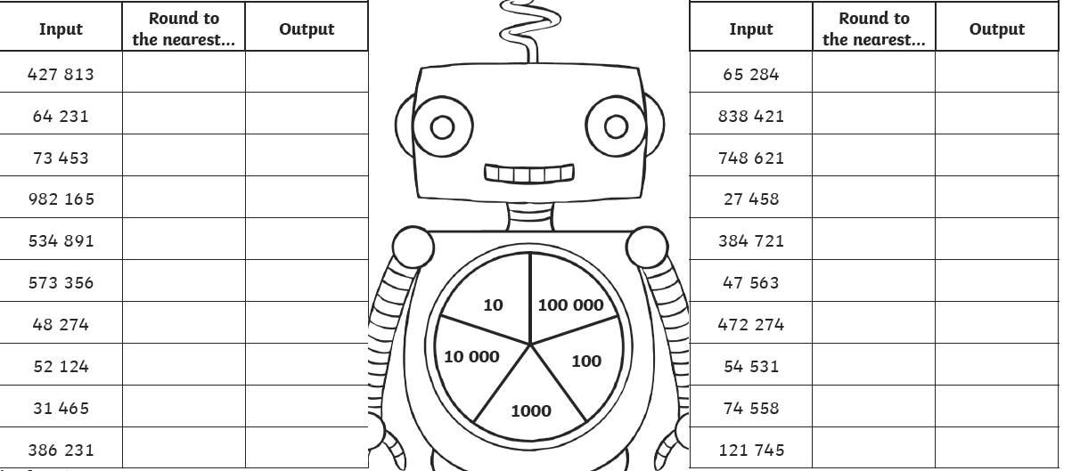
Round each number to the nearest 10, 100, 1000, 10 000 or 100 000
100 000
100 000
100 000
10 000
1000
1000
10 000
10 000
10 000
1000
100
100
100
100
10
10
10
10
10
10

