Wednesday: Picture with Questions
For this task, I would like you to look at the image and answer the questions below.
http://www.pobble365.com/animal-town
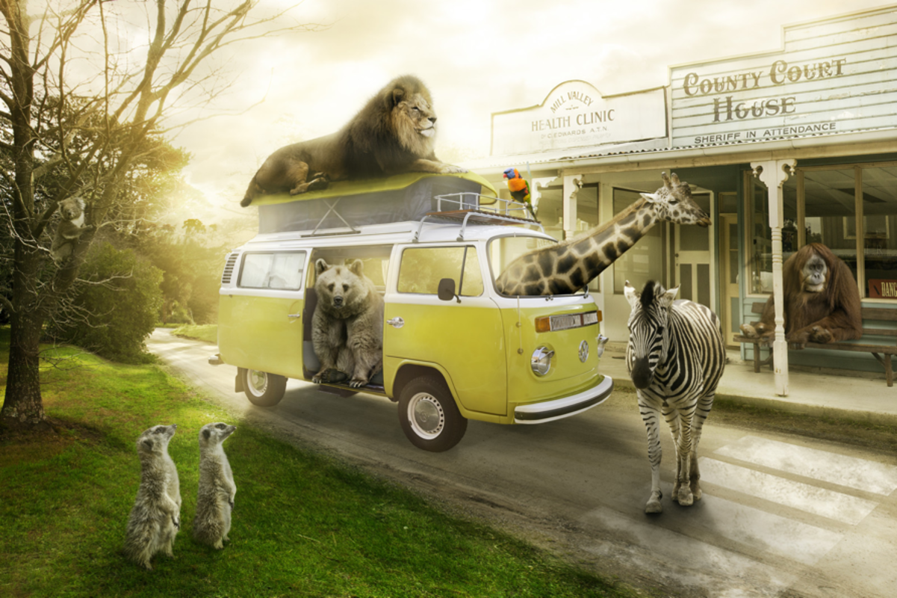
Most visitors are a little shocked when they arrive at Animal Town. Despite the fact that the name of the town gives people an idea, they don’t believe it!
This whole town is run by the animals. It might be strange to see the orang-utan behind a desk in the police office making sure people obey the law or even seeing the lion act as a doctor.
- What animals can you see in the picture?
- Where do you think the animals have been? Or where could they be going?
- Which animal looks the friendliest and why?
- What job do you think the zebra would have in this town and why?
- Do you think there would be any problems in a world that is run by animals?
Sentence Challenge:
Using our fantastic adjectives, I would like you to create as many exciting sentences about the picture above.
For example: The hungry lion lay patiently on top of the yellow campervan.

