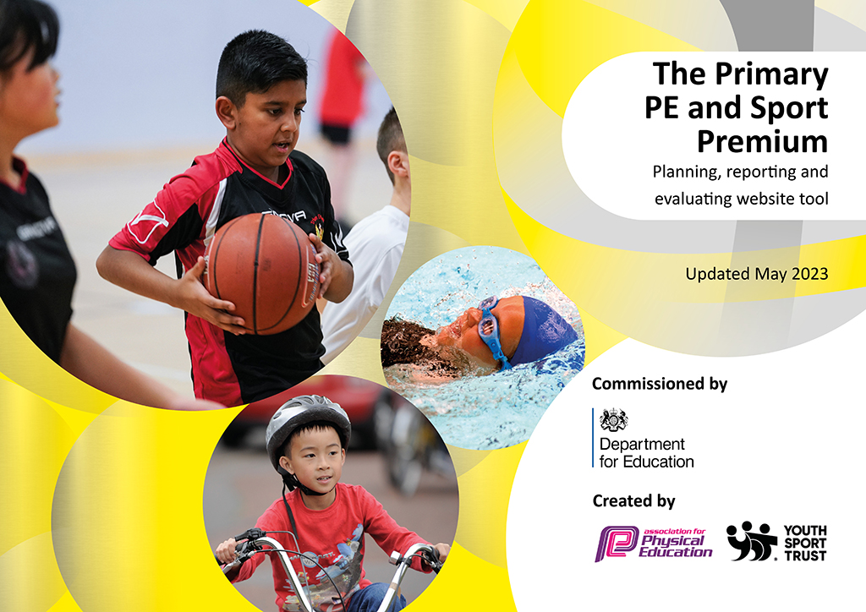
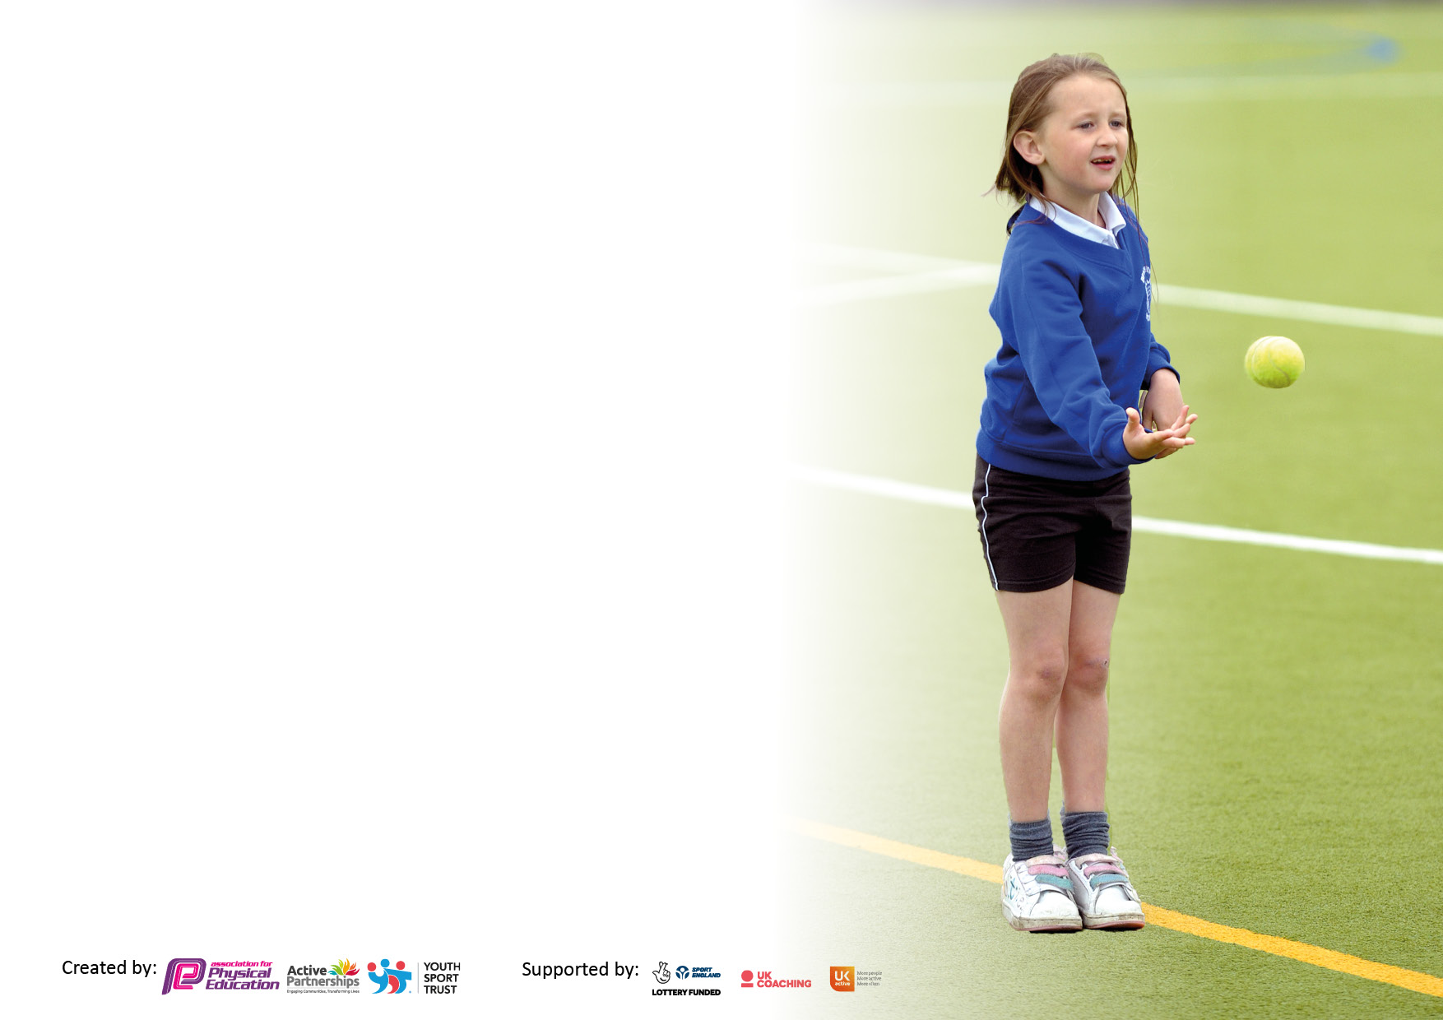

It is important that your grant is used effectively and based on school need. The Education Inspection Framework makes clear there will be a focus on ‘whether leaders and those responsible for governors all understand their respective roles and perform these in a way that enhances the effectiveness of the school’.

Under the Quality of Education Ofsted inspectors consider:
Intent - Curriculum design, coverage and appropriateness
Implementation - Curriculum delivery, Teaching (pedagogy) and Assessment
Impact - Attainment and progress

To assist schools with common transferable language this template has been developed to utilise the same three headings which should make your plans easily transferable between working documents.

Schools must use the funding to make additional and sustainable improvements to the quality of Physical Education, School Sport and Physical Activity (PESSPA) they offer. This means that you should use the Primary PE and sport premium to:

- Develop or add to the PESSPA activities that your school already offer
- Build capacity and capability within the school to ensure that improvements made now will benefit pupils joining the school in future years
- The Primary PE and sport premium should not be used to fund capital spend projects; the school’s budget should fund these.

Pleasevisitgov.ukfortherevisedDfEguidanceincludingthe5keyindicatorsacrosswhichschoolsshoulddemonstrate animprovement.Thisdocumentwillhelpyoutoreviewyourprovisionandtoreportyourspend.DfEencouragesschools to use this template as an effective way of meeting the reporting requirements of the Primary PE and Sport Premium.

We recommend you start by reflecting on the impact of current provision and reviewing the previous spend.

Schools are required to publish details of how they spend this funding, including any under-spend from 2021/2022, as well as on the impact it has on pupils’ PE and sport participation and attainment. All funding must be spent by 31st July 2023.

We recommend regularly updating the table and publishing it on your website throughout the year. This evidences your ongoing self-evaluation of how you are using the funding to secure maximum, sustainable impact. Final copy must be posted on your website by the end of the academic year and no later than the 31st July 2023. To see an example of how to complete the table please click HERE.

Details with regard to funding
Please complete the table below.

Total amount carried over from 2021/22 | £0
Total amount allocated for 2021/22 | £18 180
How much (if any) do you intend to carry over from this total fund into 2022/23? | £0
Total amount allocated for 2022/23 | £1320
Total amount of funding for 2023/23. To be spent and reported on by 31st July 2023. | £ 18 320
Swimming Data
Please report on your Swimming Data below.

Meeting national curriculum requirements for swimming and water safety.

N.B. Complete this section to your best ability. For example you might have practised safe self-rescue techniques on dry land which you can then transfer to the pool when school swimming restarts.
Due to exceptional circumstances priority should be given to ensuring that pupils can perform safe self rescue even if they do not fully meet the first two requirements of the NC programme of study
What percentage of your current Year 6 cohort swim competently, confidently and proficiently over a distance of at least 25 metres?  N.B. Even though your pupils may swim in another year please report on their attainment on leaving primary school at the end of the summer term 2022.  Please see note above | 40%
What percentage of your current Year 6 cohort use a range of strokes effectively [for example, front crawl, backstroke and breaststroke]?  Please see note above | 40%
What percentage of your current Year 6 cohort perform safe self-rescue in different water-based situations? | 30%
Schools can choose to use the Primary PE and sport premium to provide additional provision for swimming but this must be for activity over and above the national curriculum requirements. Have you used it in this way? | Yes

Action Plan and Budget Tracking
Capture your intended annual spend against the 5 key indicators. Clarify the success criteria and evidence of impact that you intend to measure to evaluate for pupils today and for the future.

Academic Year: 2022/23 | Total fund allocated: | Date Updated:
Key indicator 1: The engagement of all pupils in regular physical activity – Chief Medical Officers guidelines recommend that primary school pupils undertake at least 30 minutes of physical activity a day in school |  |  |  | Percentage of total allocation:
 |  |  |  | 1%
Intent | Implementation |  | Impact
Your school focus should be clear what you want the pupils to know and be able to do and about  what they need to learn and to  consolidate through practice: | Make sure your actions to achieve are linked to your intentions: | Funding allocated: | Evidence of impact: what do pupils now know and what can they now do? What has changed?: | Sustainability and suggested next steps:
- Provide opportunities for children to be as active as possible throughout the school day.  Raise the levels of general physical activity of all our children after long periods of in-activity due to Covid-19. | • Staff member to attend training for Ready Set Move programme – this will create a more physically active school and increase activity levels in children  •PE Lead to attend Active Schools Summit  • All KS2 pupils to access Fitness Club and Go Noodle daily  • EYFS and KS1 to complete Run, jog, walk and Go Noodle daily  • Pupils to be encouraged to take part in active playtimes – Sports Crew to run activities for KS2 classes  • Choice of equipment available at lunchtimes for pupils to choose their own activities  • Extra-curricular sports clubs target least active pupils  • Extra-curricular sports clubs change activity weekly and involve pupils in choosing activities  • Extra-curricular dance sessions for KS1 pupils delivered by qualified dance teacher  •Encourage children to get involved in Beat the Street with their parents/carers  •Encourage children to walk to school, especially during Walk to School Week in May | SL time  £200
Key indicator 2: The profile of PESSPA being raised across the school as a tool for whole school improvement |  |  |  | Percentage of total allocation:
 |  |  |  | 11%
Intent | Implementation |  | Impact
Your school focus should be clear what you want the pupils to know and be able to do and about  what they need to learn and to  consolidate through practice: | Make sure your actions to achieve are linked to your intentions: | Funding allocated: | Evidence of impact: what do pupils now know and what can they now do? What has changed?: | Sustainability and suggested next steps:
• Improve the recording of evidence of pupils’ work and progress in PE to show how they are: - developing competence to excel in a broad range of physical activities; - being physically active for sustained periods of time; - engaging in competitive sports and activities; - leading healthy, active lives; - evaluating and improving performance  • Continue to develop a whole school focus on health and fitness and relaunch our motto ‘Sweat, smile, sleep, repeat’ | •PE lead to carry out lesson drop-ins  • Teachers to take photos and videos of lessons on Primary PE App  • Pupils to be interviewed about PE to ensure we listen to pupil voice  • Evidence of competitive sport from Burnley SSP calendar  • Utilise the FMS skills system to identify children who may have gaps in their development – especially those in Years 2 and 3  • Assess using Primary PE App and ensure these are passed on to next teacher  • Refurbish the PE store so it has better access for staff  •Choose pupils to be PE Ambassadors  •Choose pupils to be Sports Crew (playground leaders) and arrange for SSCo to train them  •Choose pupils to train to be Young Mental Health Champions and attend training  •Celebrate all sporting achievements in assemblies, on PE notice board, on school newsletter and Twitter.  • Encourage all children to try to improve their health and fitness at every opportunity  •Encourage children to follow the 6 School Games Values: honesty, self belief, determination, teamwork respect and passion | SL time  See KI3  £2000  SSP buy-in 2022/23 (KI5)  SL time

Key indicator 3: Increased confidence, knowledge and skills of all staff in teaching PE and sport |  |  |  | Percentage of total allocation:
 |  |  |  | 3%
Intent | Implementation |  | Impact
Your school focus should be clear | Make sure your actions to | Funding | Evidence of impact: what do | Sustainability and suggested
what you want the pupils to know | achieve are linked to your | allocated: | pupils now know and what | next steps:
and be able to do and about | intentions: |  | can they now do? What has
what they need to learn and to |  |  | changed?:
consolidate through practice:
Ensure staff can deliver HQ PE/Sport activities. Staff should be confident and capable of delivering all areas of the curriculum to a range of ages/abilities. | • Continue to use the Primary PE App for all staff to use for planning, teaching and assessing PE  •Conduct lesson drop-ins and feedback to staff  • Audit staff skills and identify any areas of weakness  •Access any relevant training through the SSP CPD program and direct to appropriate member of staff  • Audit equipment and order new to ensure every child has access during lessons  • Employ PE coach to teach PE and sport, deliver Fitness Club and extra-curricular sessions, attend inter-school competitions and to support staff  •Staff to observe our PE coach teaching PE and sport to ensure HQ lessons are being delivered  • Staff to look for success physically, cognitively, socially and emotionally to ensure every child can be successful and can achieve  • Staff to use resources that allow for High Quality teaching and learning. | £550  SSP buy-in 2022/23(KI5)  See KI 4
Key indicator 4: Broader experience of a range of sports and activities offered to all pupils |  |  |  | Percentage of total allocation:
 |  |  |  | 60%
Intent | Implementation |  | Impact
Your school focus should be clear | Make sure your actions to | Funding | Evidence of impact: what do | Sustainability and suggested
what you want the pupils to know | achieve are linked to your | allocated: | pupils now know and what | next steps:
and be able to do and about | intentions: |  | can they now do? What has
what they need to learn and to |  |  | changed?:
consolidate through practice:
• Provide a wide range of learning opportunities for pupils, exposing them to different types of activities in different settings. | •Organise Pool for Schools – on-site swimming pool with qualifies staff to deliver high quality swimming session to every child over 2 weeks.  •Continue to focus on the schools swimming program, providing Year 6 pupils with ‘top up’ swimming lessons for those not able to swim 25m  • Continue to employ designated staff to deliver PE curriculum lessons, extra-curricular activities and competitions  •Update school playground to give more opportunities for active playtimes/lunchtimes  • Update and maintain resources for PE and lunchtime/after school activities  • Utilise the coaching available through SSP buy in: Dance, Bikeability, Cricket, Rugby, Gymnastics, Healthy Eating, Tots on Tyres, Skills to Play  • Ask pupils what activities they would like to try for after school clubs and Golden Time  • Use Golden Time sport and after school clubs to offer non-curriculum sport/activities e.g archery  • PE lead to ensure every child in KS2 gets the opportunity to attend an after-school club  • PE lead to ensure every child in Years 5 and 6 gets the opportunity to represent school in inter-school competition  • PE lead to ensure every child in KS2 gets the opportunity to take part in intra-school competition | £3700  £715  £5155  £1500  SSP buy-in 2022/23 (KI5)

Key indicator 5: Increased participation in competitive sport |  |  |  | Percentage of total allocation:
 |  |  |  | 25%
Intent | Implementation |  | Impact
Your school focus should be clear | Make sure your actions to | Funding | Evidence of impact: what do | Sustainability and suggested
what you want the pupils to know | achieve are linked to your | allocated: | pupils now know and what | next steps:
and be able to do and about | intentions: |  | can they now do? What has
what they need to learn and to |  |  | changed?:
consolidate through practice:
• Provide as many competitive opportunities for pupils on the school site. Establish Intra School competitions during the curriculum and access inter-school competitions  • Buy into local SSP to ensure continuity and growth of local infrastructure. Universal offer for pupils and coordinated support package. Maintain links with other local providers | •Ensure all lessons have elements of competition (personal best)  • Access inter-school competitions including friendly fixtures and SSP off- site events  • Organise friendly competitions with neighbouring school  • Organise competitive Sports Day and School Games Day  • PE lead to ensure every child in Year 6 and as many other pupils as possible have the opportunity to compete against pupils from other schools  • Staff to celebrate learning in curriculum lessons by including intra-school competition  • PE lead to ensure every child in KS2 gets the opportunity to take part in intra-school competition  • Access all SSP has to offer including: face to face competition calendar, virtual competitions, CPD courses, School Sport Coaching Programme, training for Pupil Mental Health Champions, inset for PE leads, network support for PE leads and head teachers, YST Membership enabling us to link with a national network. | SSP buy-in 2022/23 (KI5)  SSP buy-in 2022/23  £4500

Signed off by
Head Teacher: | H Bibby
Date: | 15.08.23
Subject Leader: | K Stannard
Date: | 30.07.23
Governor: | Mrs C Knight
Date: | 15.08.23

