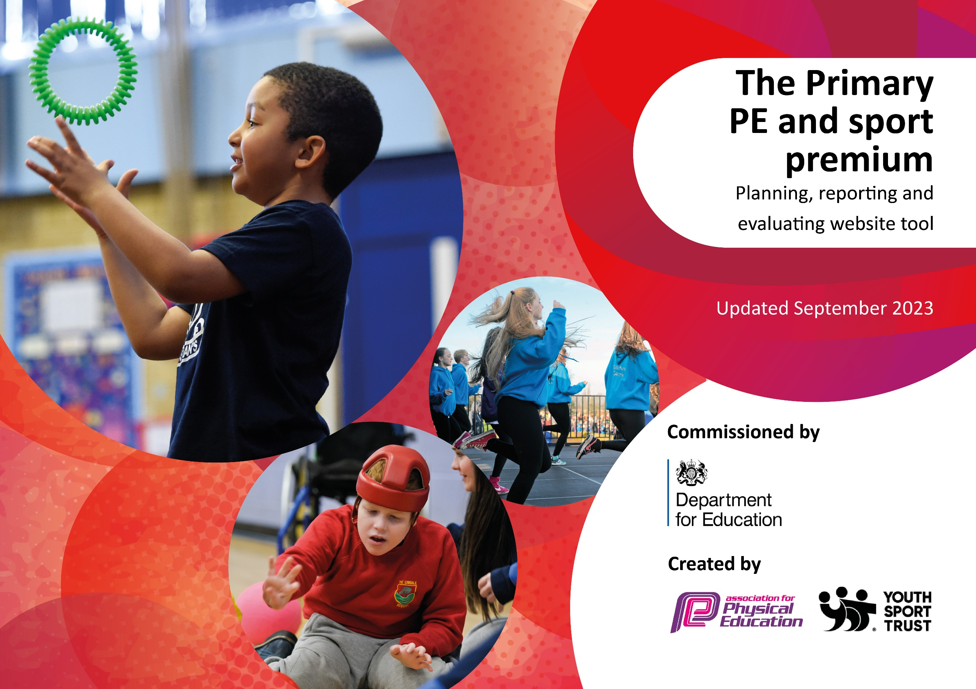

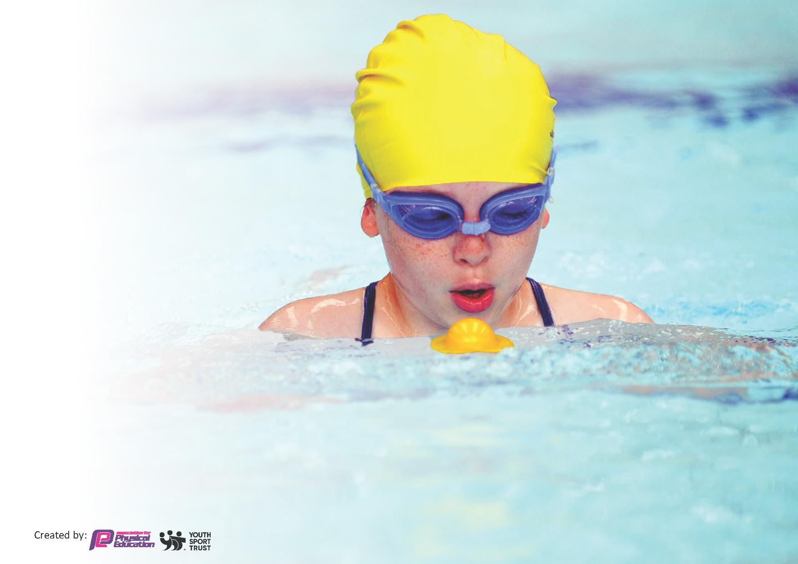
This template can be used for multiple purposes:
by:
- It enables schools to effectively plan their use of the Primary PE and sport premium
- It helps schools to meet the requirements (as set out in guidance) to publish information on their Primary PE and sport premium
- It will be an effective document to support Ofsted inspections enabling schools to evidence progress in Physical Education (PE) and evidence swimming attainment, which forms part of the PE National Curriculum. We would recommend schools consider
the Intent, Implementation and Impact of any spend, as examined within the Education Inspection Framework.

It is important that your grant is used effectively and based on school need.

Schools must use the funding to make additional and sustainable
improvements to the quality of the PE, School Sport and Physical Activity (PESSPA)
they offer. This means that you should use the Primary PE and sport premium to:

- Build capacity and capability within the school to ensure that improvements made now will benefit pupils joining the school in future years
- Develop or add to the PESSPA activities that your school already offers.

The Primary PE and sport premium should not be used to fund capital spend projects; the school’s core budget should fund these. Further detail on capital expenditure can be found in the updated Primary PE and sport premium guidance.

The Primary PE and sport premium guidance, outlines 5 key priorities that funding should be used towards. It is not

necessary that spending has to meet all the key priorities, you should select the priorities that you aim to use any funding towards.

Although completing this template is not a requirement for schools, schools are required to publish details of how they spend this funding. Schools must also outline what the impact this funding has had on pupils’ PE and sport participation and attainment and how any spending will be sustainable in the future. All funding must be spent by 31st July 2024.

The Department for Education has worked closely with the Association for Physical Education (afPE) and the Youth Sport Trust (YST) to develop this template and encourages schools to use it. This template is an effective way of meeting the reporting requirements of the Primary PE and sport premium.
Review of last year’s spend and key achievements (2022/2023)

We recommend you start by reflecting on the impact of current provision and reviewing your previous spend.

Activity/Action | Impact | Comments
• Staff member attended training for Ready Set Move programme (ongoing this year) and PE Lead to attend Active Schools Summit  • All pupils accessed Run Jog Walk, Fitness Club or Go Noodle daily; pupils to be encouraged to take part in active playtimes – Sports Crew to run activities for KS2 classes; choice of equipment available at lunchtimes for pupils to choose their own activities  • Extra-curricular sports clubs targeted least active, SEND and disadvantaged pupils.  • Extra-curricular dance/cheer sessions for KS1 pupils delivered by qualified dance teacher  •Encourage children to get involved in Beat the Street with their parents/carers  •PE Ambassadors, Sports Crew (playground leaders) and Young Mental Health Champions attended training.  • Continued to use the Primary PE App for planning, teaching and assessing PE.  • Employed PE coach to teach PE and sport, deliver Fitness Club and extra-curricular sessions, attend inter-school competitions and to support staff  •Organised Pools for Schools – on-site swimming pool with qualified staff to deliver high quality swimming session to every child over 2 weeks.  •Continued to focus on the schools swimming program, providing Year 6 pupils with ‘top up’ swimming lessons for those not able to swim 25m  • Utilised the coaching available through SSP buy in: Dance, Bikeability, Cricket, Rugby, Gymnastics, Healthy Eating, Tots on Tyres, Skills to Play  • PE lead ensured every child in KS2 had the opportunities to attend an after-school club and to take part in intra-school competition  • PE lead to ensure every child in Year 6 and as many other pupils as possible had the opportunity to compete in inter-school competitions. | Ideas for how to create a more physically active school and increase activity levels in children.  Increased involvement of less active pupils.  Children enjoyed attending and grew in confidence.  Children enjoyed sessions.  Children, parents and staff all enjoyed the challenge and increased activity levels.  Pupils took pride in their roles and supported many children with their physical and mental health.  Primary PE App used to chart pupils’ progress in PE.  PE coach encouraged all pupils and staff to be more active.  All pupils accessed swimming session. Water confidence was raised in every session.  Year 6 pupils made progress during these sessions.  Pupils experienced high quality coaching and staff experienced skills to help them teach high quality lessons.  60% of KS2 pupils attended after-school clubs and 100% took part in inter-school competitions. All pupils had positive experiences and increased activity levels.  Every child in Year 6 represented school in inter-school sports and gained valuable experiences. | Children are moving more during assemblies and classroom-based lessons  Children attended who had never been before.  Class teachers commented on pupils’ enjoyment.  Parents gave positive feedback.  Pupils’ have now gone on to partake in similar roles at high school.  Evidence of high quality lessons and progression.  PE coach seen as a positive role model by pupils and parents.  Pupils had positive experiences – some had never been swimming before.  Pupils confidence grown – some had not been swimming since Pools For Schools sessions.  High-quality sessions enjoyed by pupils.  Some pupils not wanting to attend after-school clubs even when offered a place.  Every pupil felt proud to represent school. Comments from other schools about their positive behaviour.

Key priorities and Planning
This planning template will allow schools to accurately plan their spending.

Action – what are you planning to do | Who does this action impact? | Key indicator to meet | Impacts and how sustainability will be achieved? | Cost linked to the action
Increase the engagement of all pupils in physical activity through fitness club, active playtimes and lunchtime games  Organise CPD for staff. Sports coaches to increase knowledge, confidence and skills of staff in teaching PE.  Buy membership for Burnley School Sports partnership  Purchase additional PE resources to ensure high quality PE lessons are delivered and a range of activities are offered  All children to access swimming lessons through Pools For Schools and Year 6 pupils to have top-up swimming sessions in the summer term | Staff and pupils – as they will take part.  Staff and pupils  PE lead/staff/pupils  PE lead/staff/pupils  Pupils | Key indicator 2 -The engagement of all pupils in regular physical activity – the Chief Medical Officer guidelines recommend that all children and young people aged 5 to 18 engage in at least 60 minutes of physical activity per day, of which 30 minutes should be in school.  Key indicator 4: Broader experience of a range of sports and activities offered to all pupils  Key Indicator 1: Increased confidence, knowledge, and skills of all staff in teaching PE and sport.  Key indicator 5: Increased participation in competitive sport.  Key Indicator 1: Increased confidence, knowledge, and skills of all staff in teaching PE and sport.  Key indicator 5: Increased participation in competitive sport.  Key indicator 2 -The engagement of all pupils in regular physical activity – the Chief Medical Officer guidelines recommend that all children and young people aged 5 to 18 engage in at least 60 minutes of physical activity per day, of which 30 minutes should be in school.  Key indicator 4: Broader experience of a range of sports and activities offered to all pupils.  Key indicator 2 -The engagement of all pupils in regular physical activity – the Chief Medical Officer guidelines recommend that all children and young people aged 5 to 18 engage in at least 60 minutes of physical activity per day, of which 30 minutes should be in school. | More pupils meeting their daily physical activity goal, more pupils encouraged to take part in PE and Sport activities.  Sports Crew to have experience leading activities.  Primary teachers more confident to deliver effective PE supporting pupils to undertake extra activities inside and outside of school, including teaching water safety and swimming and as a result improved % of pupil’s attainment in PE.  To engage further in local cluster meetings and networking. To be further involved in local sporting competitions and events  Resources purchased to improve fitness in pupils and  enjoyment in sport.  All children to be able to swim by the end of Year 6 | £827.74 (playtime equipment)  £699 (Primary PE App)  £5750 (sports coach)  Burnley SSP buy-in (see next row)  £6000 (Burnley School Sports Partnership)  £793.26  £3500 (Pools to Schools)  £750 (Y6 Top-up)

Key achievements 2023-2024
This template will be completed at the end of the academic year and will showcase the key achievements schools have made with their Primary PE and sport premium spending.

Activity/Action | Impact | Comments
Increase the engagement of all pupils in physical activity through fitness club, active playtimes and lunchtime games  Organise CPD for staff. Sports coaches to increase knowledge, confidence and skills of staff in teaching PE.  Buy membership for Burnley School Sports partnership  Purchase additional PE resources to ensure high quality PE lessons are delivered and a range of activities are offered  All children to access swimming lessons through Pools For Schools and Year 6 pupils to have top-up swimming sessions in the summer term. | More pupils are meeting their daily physical activity goals, more pupils have taken part in PE and Sport activities outside curriculum PE. Sports Crew pupils have experienced leading activities at playtimes. Play/lunchtime resources have increased engagement. Pupils experiencing different activities e.g. swing-ball, skipping, etc.  Staff members have had CPD through sports coaches in different areas of PE e.g. athletics, dance, cricket, gymnastics, rounders, rugby. Staff feel more confident teaching high quality PE.  Pupils have been involved in local sporting competitions and events. SEND, non-engaged pupils and non-sporty girls have represented school in sporting activities.  Resources purchased to improve fitness in pupils and enjoyment in sport.  Every pupil accessed swimming lessons through Pools For Schools. All pupils feel more confident in water. Year 6 accessed top-up swimming lessons. All pupils improved water confidence and swimming ability. | All pupils more engaged in physical activity. Behaviour at play/lunchtimes is good.  Staff feel more confident teaching high quality PE.  Every Year 6 pupil has represented inter-school in a sporting event. Every pupil felt proud to represent school. SEND pupils, non-active pupils and non-sporty girls represented school. Comments from other schools about their sportsmanship and positive behaviour.  All staff delivering high-quality PE lessons. Adaptations being made for SEND pupils so all learners access the lesson.  All pupils enjoyed swimming lessons. Some children only swim with school.

Swimming Data
Meeting National Curriculum requirements for swimming and water safety.
Priority should always be given to ensuring that pupils can perform safe self-rescue even if they do not fully meet the first two requirements of the National Curriculum programme of study

Question | Stats: | Further context  Relative to local challenges
What percentage of your current Year 6 cohort can swim competently, confidently and proficiently over a distance of at least 25 metres? | 44% | This cohort went swimming in Year 3 but the lessons were cancelled due to Covid 19. Most pupils do not go swimming outside the curriculum. All pupils used Pools to School sessions in Year 5 and Year 6.
What percentage of your current Year 6 cohort can use a range of strokes effectively [for example, front crawl, backstroke, and breaststroke]? | 34% | See above.

What percentage of your current Year 6 cohort are able to perform safe self-rescue in different water-based situations? | 25% | See above.
If your schools swimming data is below national expectation, you can choose to use the Primary PE and sport premium to provide additional top-up sessions for those pupils that did not meet National Curriculum  requirements after the completion of core lessons. Have you done this? | Yes
Have you provided CPD to improve the knowledge and confidence of staff to be able to teach swimming and water safety? | No

Signed off by:

Head Teacher: | Helen Bibby
Subject Leader or the individual responsible for the Primary PE and sport premium: | Kerry Stannard
Governor: | Claire Knight  PE Governor
Date: | 18.07.24

