Maths Homework 25.4.25
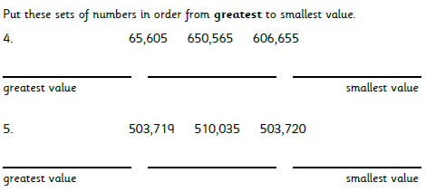
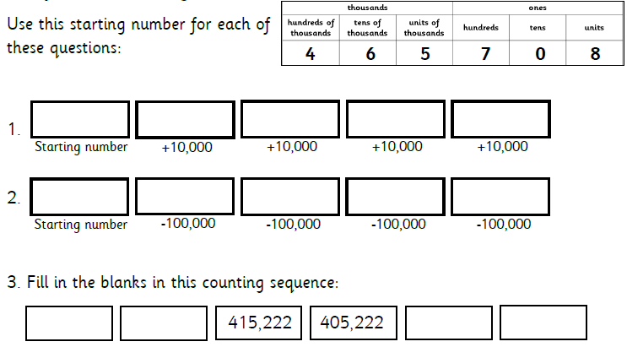
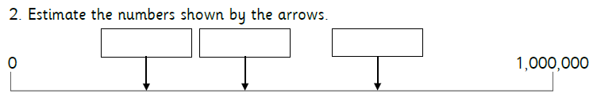

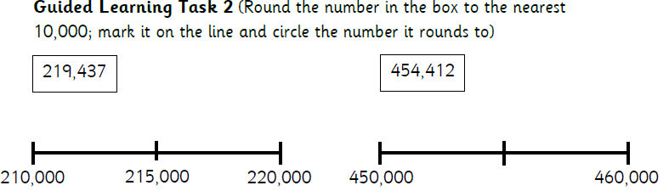
communicate
communicates
communicating
communication
community
communicates
miscommunicate
miscommunicates
miscommunication
miscommunicates

