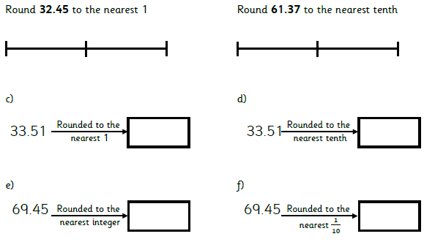
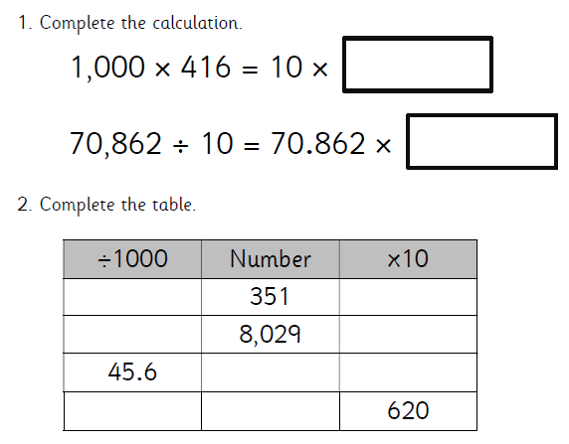

Contradict
Controversy
Contradicted
Contradicting
Contradiction
Contradictory
Contradicts
Controversial
Controversially
(only 9)

