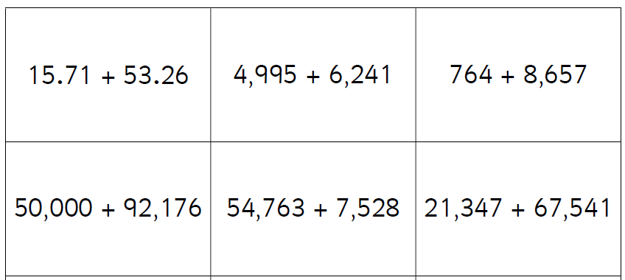
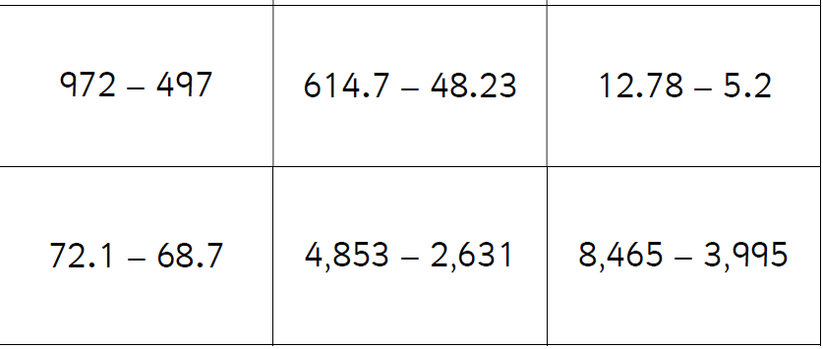
Restaurant
Restaurants
Storage
Stored
Stores
Restore
Restauration
Restored
Restores
Restoring

