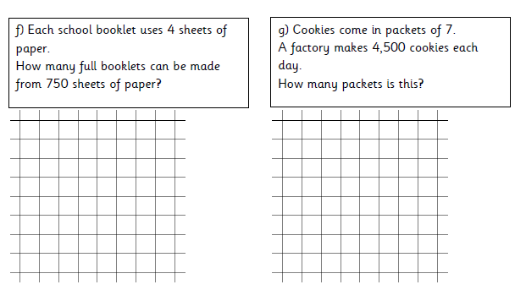
Represent remainders as fractions
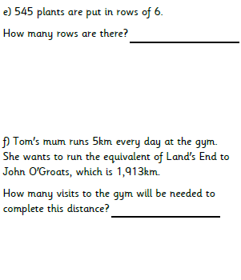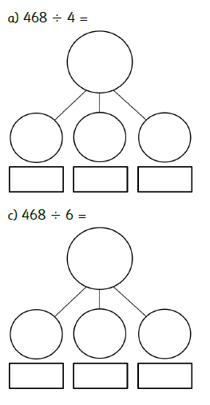

Exaggerate
Existence
Exaggerated
Exaggerating
Exaggeration
Exaggerates
Exist
Existed
Existing
Exists

