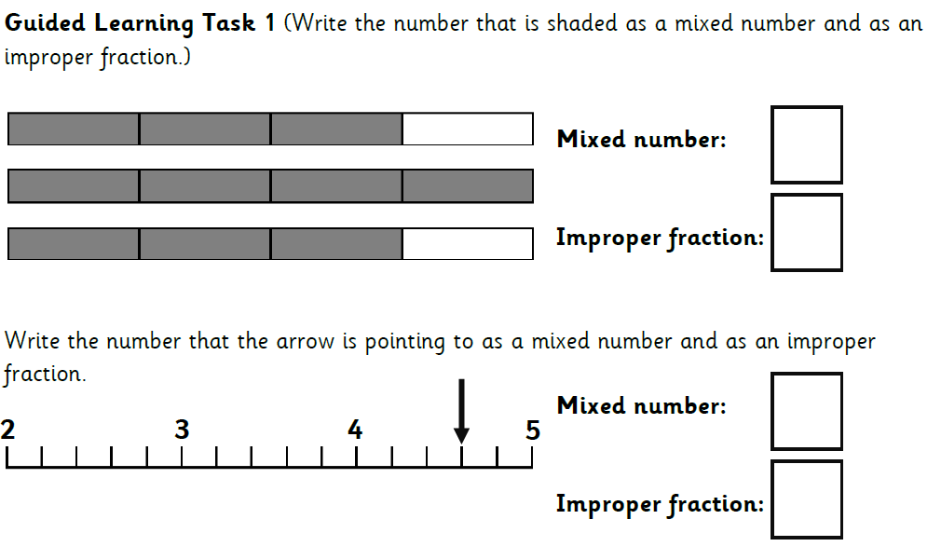
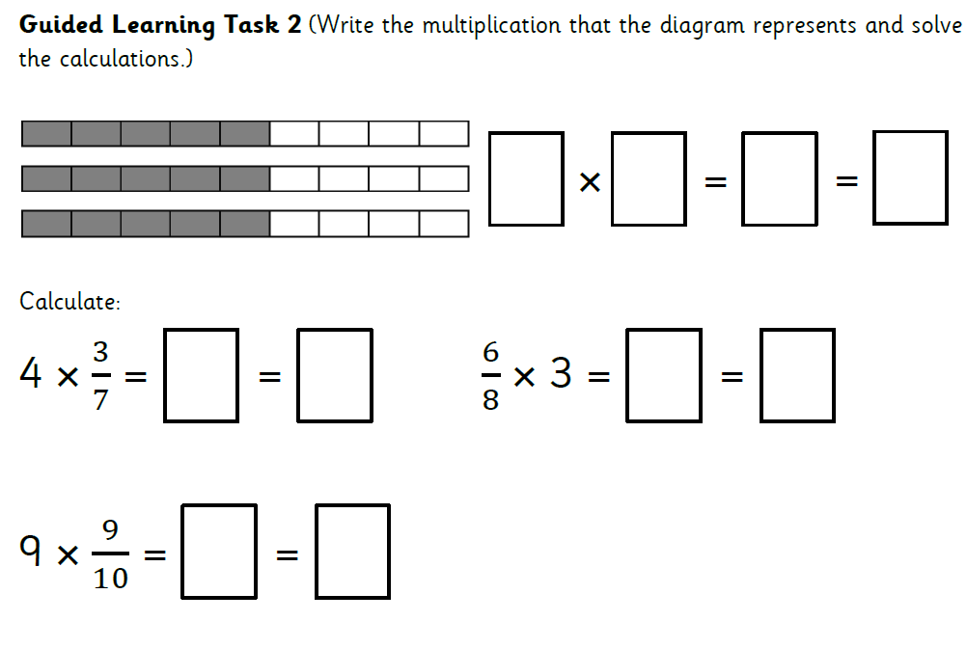

Embarrass
Embarrassment
Embarrassed
Embarrasses
Embarrassing
Embarrassingly
Harassed
Harasses
Harassing
Harassment

