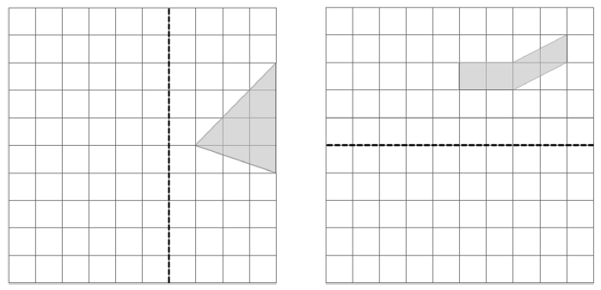
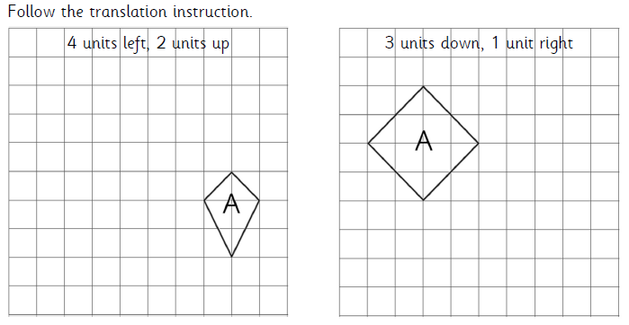
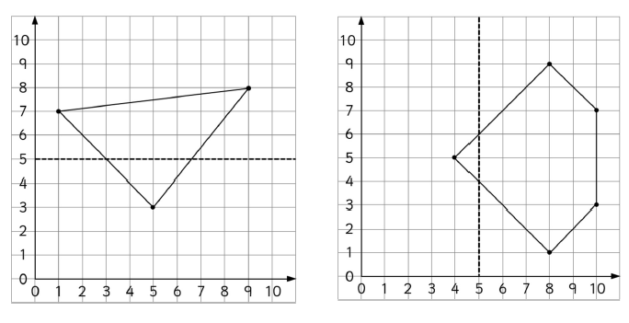
Neighbour
Neighbourhood
Neighbourly
Neighbouring
Physical
Physically
Physics
Physician
Shoulder
Shoulders
Shouldering

