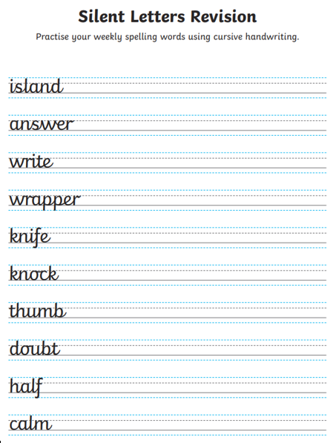 Write each of the words in a sentence. Try to include a subordinate clause.

