Appendix A - Key Staff and Contacts

School-based contacts

Role | Contact details
Headteacher | Helen Bibby
Designated Safeguarding Lead | Stacey Thompson
Deputy Designated Safeguarding Lead | Helen Bibby
E-Safety Lead | Lewis Birtwistle
Prevent Duty Lead | Helen Cameron
Designated Teacher with responsibility for Young Carers | Stacey Thompson
Designated Teacher for Looked After and Previously Looked After Children | Stacey Thompson
Nominated Safeguarding Governor | Michael Mulrooney
All of the above can be contacted via the school office on 01282438120

Other useful contacts

Agency / Contact | Contact Details
INSERT MULTI-ACADEMY TRUST or LA Contacts
Head of Safeguarding Romero Catholic Academy Trust | Rebecca.birtwistle@romerocat.com
LCC School Safeguarding Officers | 01772 531196
Lancashire Prevent Team | 01254 585260  Prevent.team@blackburn.gov.uk
LCC MASH Education Officers | 0300 123 6720
Local contacts
The Local Authority Designated Officer (LADO) | 01772 536694  LADO.admin@lancashire.gov.uk
NSPCC Whistleblowing Advice Line | 0800 028 0285  help@nspcc.org.uk

Operation encompass
Our school participates in the Operation Encompass partnership scheme, between local school, academies, colleges, community health agencies, and Lancashire Police. Operation Encompass was set up to provide early reporting to schools etc., about any domestic abuse incidents that occur outside of school hours to which a young person attending our school has been exposed, and which might then have an impact on their schooling the following day. This information will be shared throughout the year, including school holidays and the weekends. Information will only be shared with the school by the police where it is identified that a young person was present, witnessed or was involved in a domestic abuse incident. A nominated member of college staff, known as an Encompass Key Adult, has been trained to liaise with the police and speak with the children concerned if deemed appropriate. Our Key Adult is Mrs Thompson.

Low-level concerns about an adult working in or on behalf of the school
All concerns must be reported without delay to the Headteacher. In their absence, it must be reported to
Name | Role | Contact Number
Stacey Thompson | DSL | 01282438120
If the allegation or concern relates to the Headteacher/Principal, it should be reported, without delay, to the Chief Executive of Romero Catholic Academy Trust.
Name | Role | Contact Number
Katy Cox | Chief Executive Officer  Romero Catholic Academy Trust | 01282-855500

Appendix B – Curriculum
St John the Baptist RC Primary school teaches children how to keep safe through a carefully planned Relationships, Sex and Health Education (RSHE) curriculum rooted in Gospel values and the belief that every person is made in the image and likeness of God. Using the Ten: Ten Life to the Full programme, children learn about healthy relationships, personal safety, online safety, boundaries, respect for themselves and others, and how to seek help when they feel worried or unsafe. These lessons help pupils develop the knowledge, confidence and skills needed to make safe choices, build positive relationships and flourish as children of God. St John's Burnley RSHE Policy highlights that pupils are taught about online relationships, being safe and internet safety within a Catholic framework.

Appendix C Filtering and monitoring
The school uses the following filtering and monitoring system: Netsweeper . This gives daily updates to the safeguarding team.

The school’s E-Safety/Online Safety Lead is Lewis Birtwistle

Appendix D Gender Questioning children

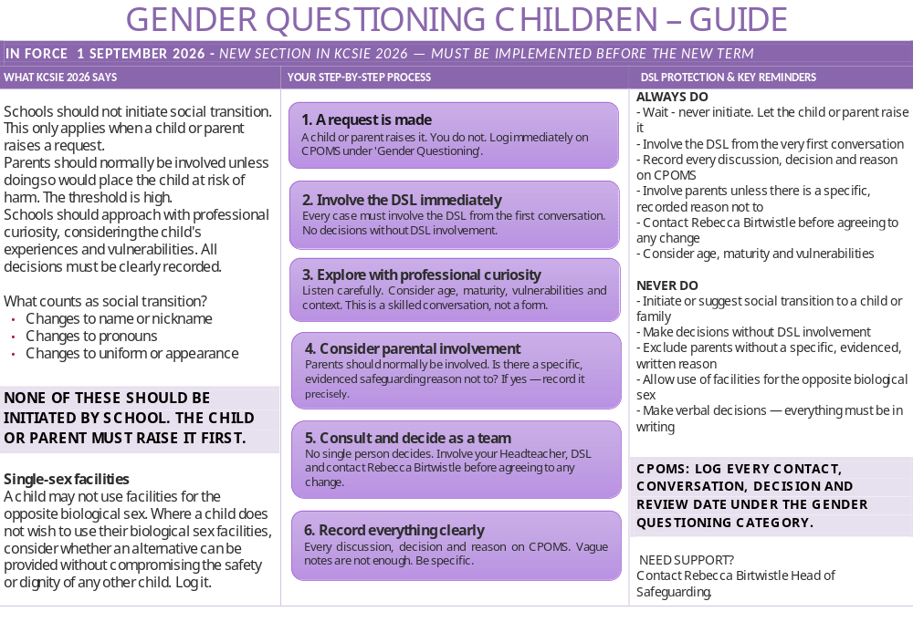

Appendix E - Four categories of abuse

Physical abuse
Physical abuse is a form of abuse which may involve hitting, shaking, throwing, poisoning, burning or scalding, drowning, suffocating or otherwise causing physical harm to a child. Physical harm may also be caused when a parent or carer fabricates the symptoms of or deliberately induces, illness in a child (this used to be called Munchausen's Syndrome by Proxy, but is now more usually referred to as fabricated or induced illness).

Emotional abuse
Emotional abuse is the persistent emotional maltreatment of a child such as to cause severe and persistent adverse effects on the child’s emotional development. It may involve conveying to a child that they are worthless or unloved, inadequate, or valued only insofar as they meet the needs of another person. It may include not giving the child opportunities to express their views, deliberately silencing them or ‘making fun’ of what they say or how they communicate. It may feature age or developmentally inappropriate expectations being imposed on children.
These may include interactions that are beyond a child's developmental capability, as well as overprotection and limitation of exploration and learning, or preventing the child from participating in normal social interaction. It may involve seeing or hearing the ill-treatment of another. It may involve serious bullying (including cyberbullying), causing children frequently to feel frightened or in danger, or the exploitation or corruption of children.
Some level of emotional abuse is involved in all types of maltreatment of a child, although it may occur alone.

Sexual abuse
Sexual abuse involves forcing or enticing a child or young person to take part in sexual activities, not necessarily involving a high level of violence, whether or not the child is aware of what is happening. The activities may involve physical contact, including assault by penetration (for example, rape or oral sex) or non-penetrative acts such as masturbation, kissing, rubbing and touching outside of clothing.
They may also include non-contact activities, such as involving children in looking at, or in the production of, sexual images, watching sexual activities, encouraging children to behave in sexually inappropriate ways, or grooming a child in preparation for abuse (including via the internet). Sexual abuse is not solely perpetrated by adult males. Women can also commit acts of sexual abuse, as can other children.

Neglect
Neglect is the persistent failure to meet a child’s basic physical and/or psychological needs, likely to result in the serious impairment of the child’s health or development. Neglect may occur during pregnancy as a result of maternal substance abuse. Once a child is born, neglect may involve a parent or carer failing to:
- provide adequate food, clothing and shelter (including exclusion from home or abandonment);
- protect a child from physical and emotional harm or danger;
- ensure adequate supervision (including the use of inadequate care-givers); or
- ensure access to appropriate medical care or treatment. It may also include neglect of, or unresponsiveness to, a child’s basic emotional needs.

Indicators of abuse
Physical signs define some types of abuse, for example, bruising, bleeding or broken bones resulting from physical or sexual abuse, or injuries sustained while a child has been inadequately supervised. The identification of physical signs is complicated, as children may go to great lengths to hide injuries, often because they are ashamed or embarrassed, or their abuser has threatened further violence or trauma if they ‘tell’. It is also quite difficult for anyone without medical training to categorise injuries into accidental or deliberate with any degree of certainty.
For these reasons, it is vital that staff are also aware of the range of behavioural indicators of abuse and report any concerns to the designated safeguarding lead.
It is the responsibility of staff to report their concerns. It is not their responsibility to investigate or decide whether a child has been abused.

A child who is being abused, neglected or exploited may:
- Have bruises, bleeding, burns, fractures or other injuries
- Show signs of pain or discomfort
- Keep arms and legs covered, even in warm weather
- Be concerned about changing for PE or swimming
- Look unkempt and uncared for
- Change their eating habits
- Have difficulty in making or sustaining friendships
- Appear fearful
- Be reckless with regard to their own or other’s safety
- Self-harm
- Frequently miss school, arrive late or leave school for part of the day
- Show signs of not wanting to go home
- Display a change in behaviour – from quiet to aggressive, or happy-go-lucky to withdrawn
- Challenge authority
- Become disinterested in their work
- Be constantly tired or preoccupied
- Be wary of physical contact
- Be involved in, or particularly knowledgeable about drugs or alcohol
- Display sexual knowledge or behaviour beyond that normally expected for their age
- Acquire gifts such as money or a mobile phone from new ‘friends’.
Individual indicators will rarely, in isolation, provide conclusive evidence of abuse. They should be viewed as part of a jigsaw, and each small piece of information will help the DSL decide how to proceed.
URGENT and Serious concerns

If a situation is URGENT and SERIOUS and the DSL/Deputy DSL cannot be contacted, immediately contact a member of the SLT to ensure the relevant agency is contacted without delay

