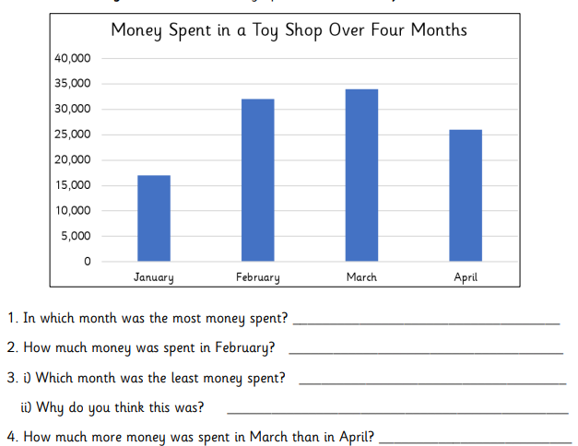
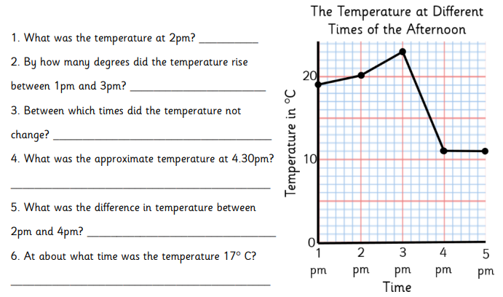

Muscle
Necessary
Sincere
Sincerely
Muscled
Sincerest
Insincerely
Insincere
Muscles

